Case Study: Market Equilibrium Price Determination (Demand–Supply)

Introduction

Market equilibrium is a fundamental concept in microeconomics that explains how prices are determined in a competitive market. It represents the point at which the quantity demanded by consumers equals the quantity supplied by producers. At this stage, there is neither excess supply (surplus) nor excess demand (shortage), ensuring stability in the market.

1) Problem Context
A local bottled cold coffee seller in Mumbai wants to set the right selling price so that:
- Customers are willing to buy (demand),
- The seller can supply that quantity (supply),
- There is no shortage and no surplus.
In economics, that “best balance point” is called market equilibrium.
The equation we will use in problem will be
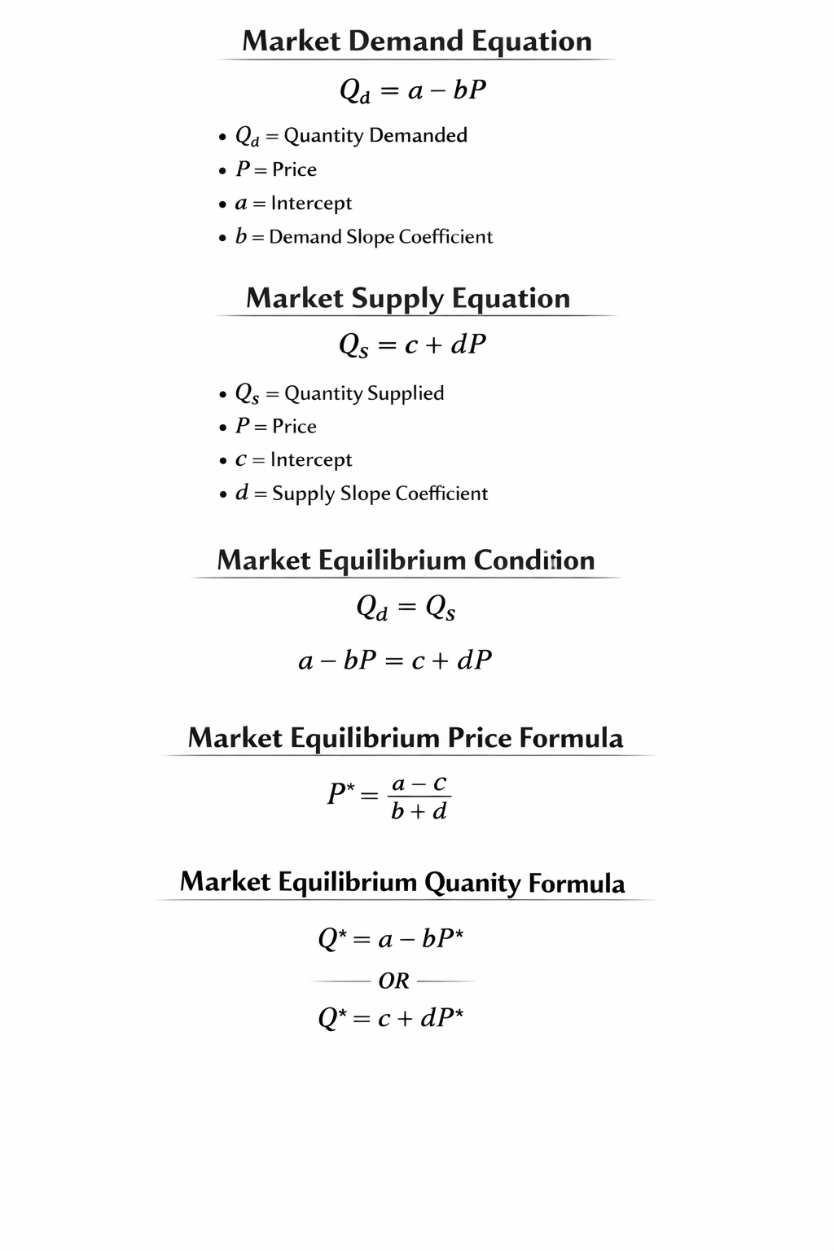

2) Given Data (Assumed from a quick local survey)
From observation, the business estimates:
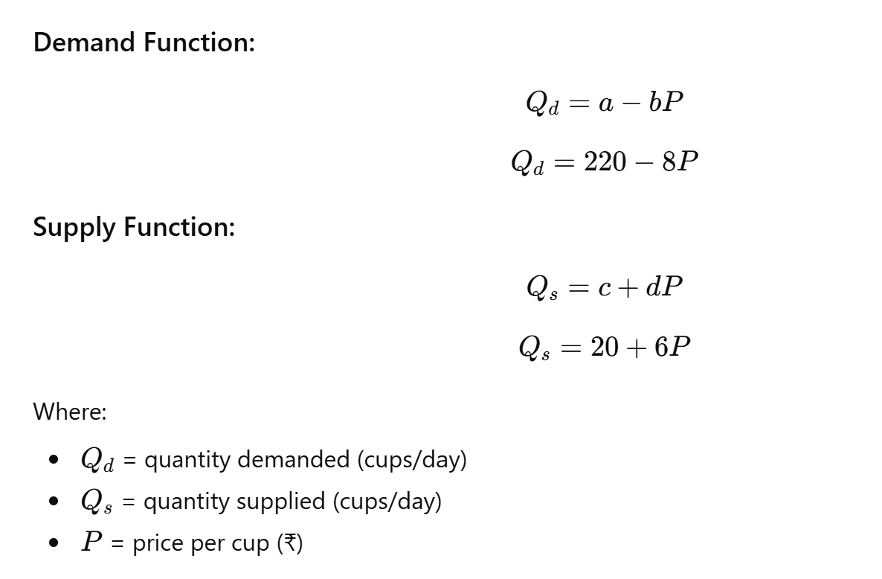

3) Equilibrium Condition
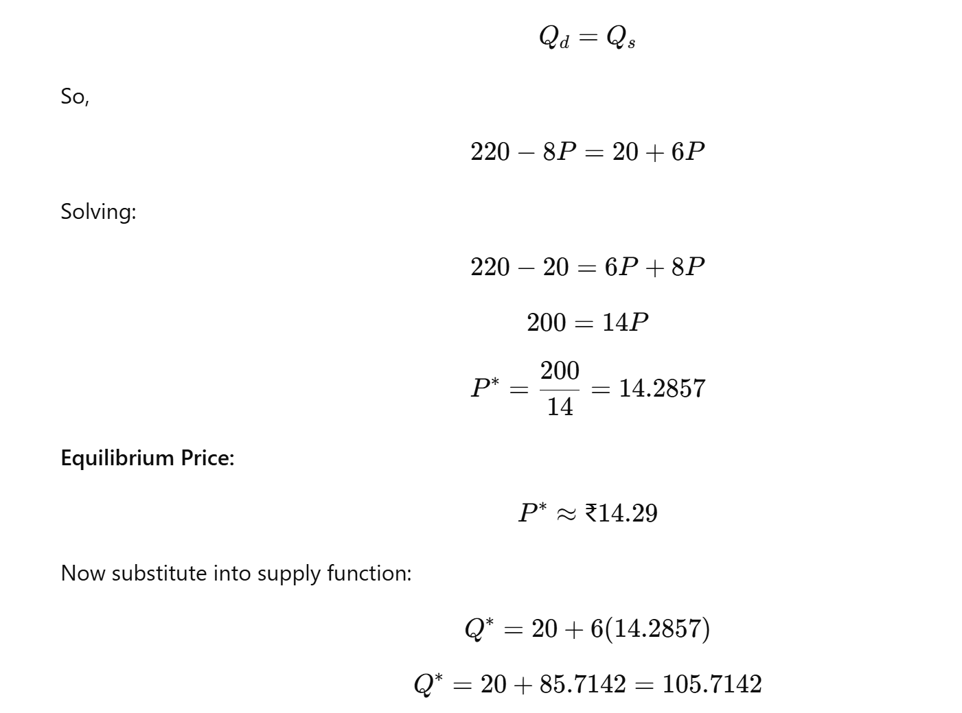
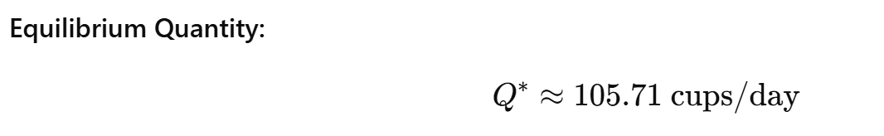

4) Interpretation (Real Meaning)
- If price is higher than ₹14.29, supply becomes higher than demand → surplus (unsold coffee).
- If price is lower than ₹14.29, demand becomes higher than supply → shortage (people want more than you can provide).
- At ₹14.29, the market naturally balances → best operating point.

5) General Formula (Quick Equilibrium Formula)
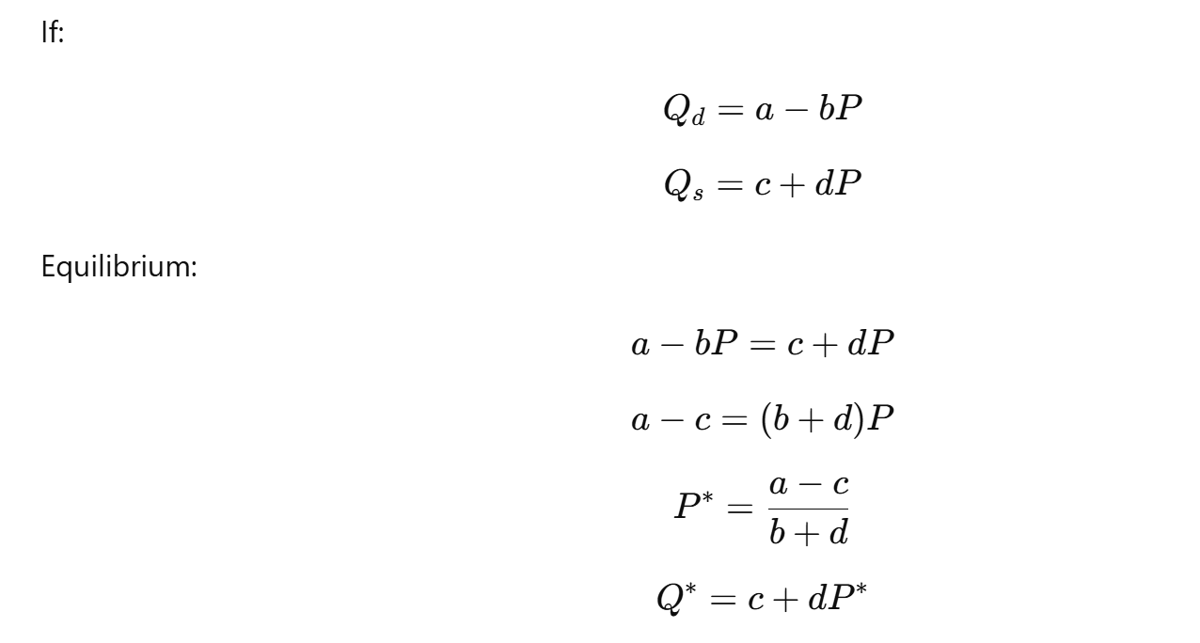

MATLAB CODE : 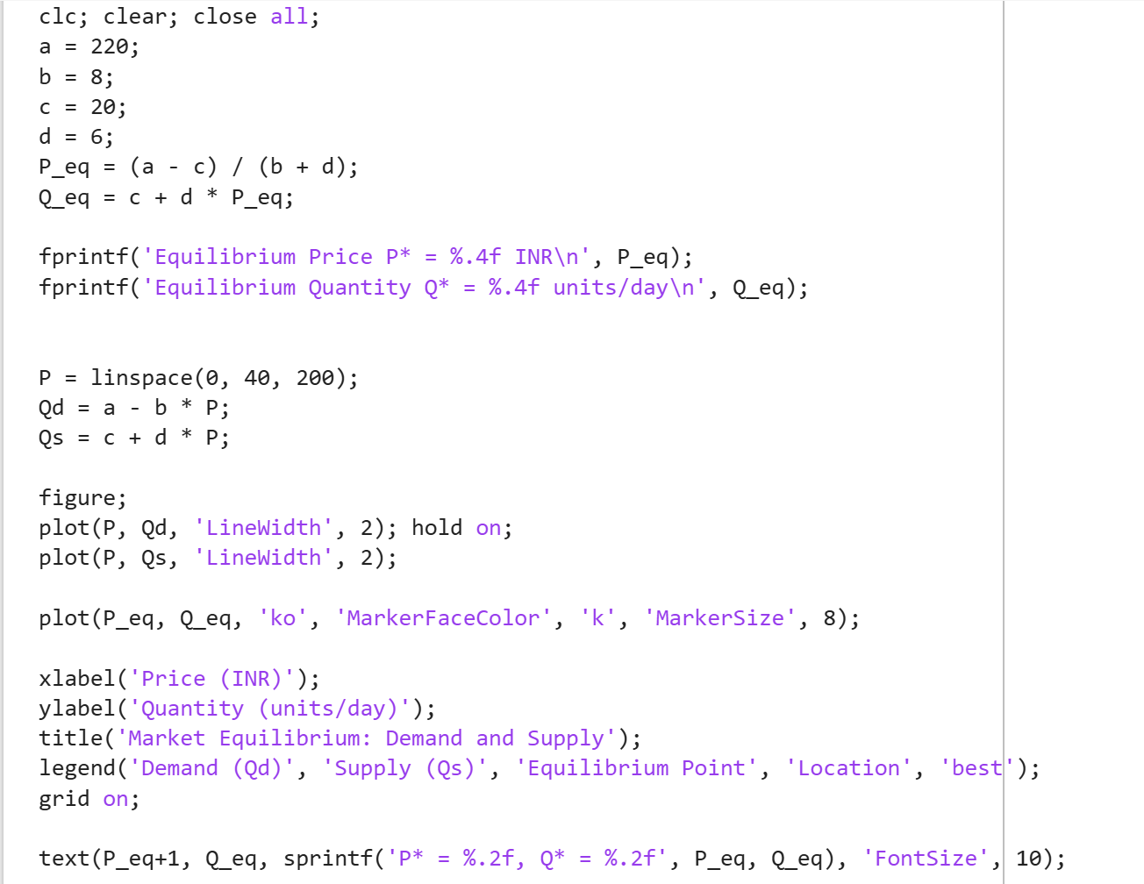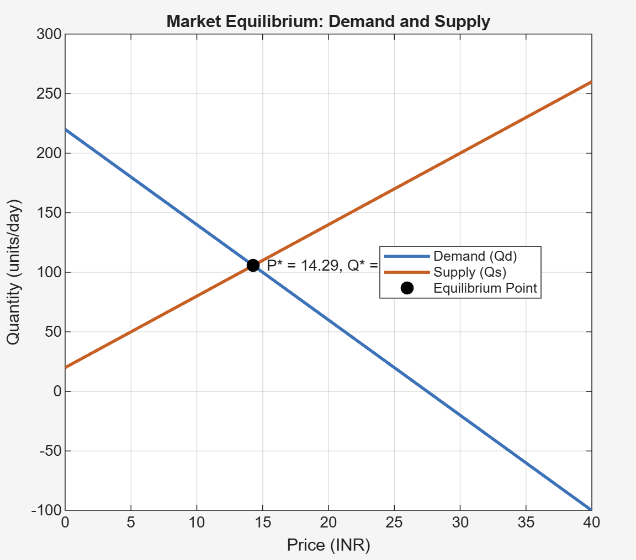

Conclusion
From the analysis, the equilibrium price and equilibrium quantity were successfully determined using mathematical equations derived from demand and supply functions. The equilibrium price was found by equating quantity demanded and quantity supplied, ensuring that the market clears without surplus or shortage.
The study demonstrates that price plays a critical role in balancing market forces. If the price rises above equilibrium, surplus occurs; if it falls below equilibrium, shortage occurs. Therefore, equilibrium price acts as a self-regulating mechanism in a competitive market.
The use of MATLAB further strengthens the analysis by providing numerical accuracy and graphical visualization of the demand and supply curves along with the equilibrium point. This case study highlights how economic theory and computational tools can be combined effectively for practical decision-making in real-world market situations.

